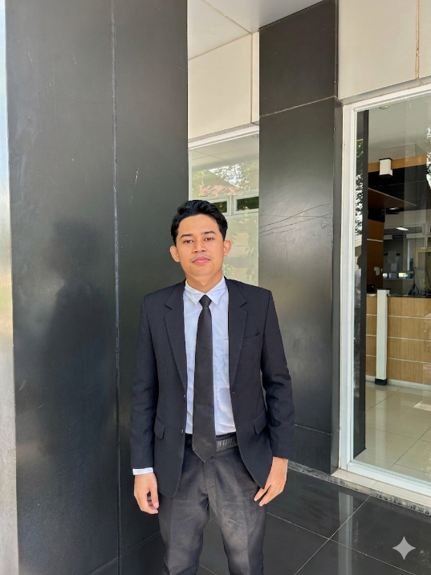
MUHAMMAD HABIL AS-SIDIK
3D Drafter & Process Engineering Enthusiast | Freshgraduate of Industrial Engineering
University Sultan Ageng Tirtayasa (UNTIRTA) Cilegon
WA : 08998651380
LinkedIn : https://www.linkedin.com/in/muhammad-habil-as-sidik
Email : sidikhabil5@gmail.com
Portfolio :

Profile
Industrial Engineering graduate from Sultan Ageng Tirtayasa University with a strong specialization and deep interest in 3D Modelling, Technical Drafting, and Facility Layout Design. Experienced in AutoCAD with practical experience using Blender. Proficient in designing technical drawings (2D/3D) for manufacturing components and optimizing facility layouts. Seeking opportunities as a 3D Drafter/Designer to contribute accurate, detailed, and efficient designs to the company.

Skills and Interest
- Design & Drafting: 3D Modelling, 2D Drafting, Technical Drawing, Facility Layout Design, Product Conceptualization.
- Software: AutoCAD, Blender, Microsoft Visio, Solid-works, Microsoft Excel.
- Industrial Engineering: Production Planning & Inventory Control, Kaizen (Continuous Improvement), Work System Measurement.

Relevant Design Projects
- CNC Machine 2D & 3D Modelling: Designed 3D models and 2D drafting for CNC machine components using AutoCAD, strictly adhering to precision standards and technical specifications.
- Product Design - Phone Holder: Conceptualized, shaped, and created 3D models for a phone holder product using Blender software.
- Facility Layout Optimization: Designed the company's facility layout and production flow using Microsoft Visio to visualize spatial optimization and workflow efficiency.

Work Experiences
Production System Laboratory UNTIRTA June 2024 - Present
Laboratory Assistant
Key Achievements
- Monitoring 350 students to carry out practical activities according to SOP and ensuring that students successfully complete practical assignments.
Responsibilities
- Designing and implementing technical drawing practicum.
- Designing and implementing manufacturing process practicum.
- Designing and implementing facility layout practicum.
- Designing and implementing integrated practicum.

PT Krakatau Jasa Industri (KJI) Apr 2026 – Present
Legal Officer Intern - internship
Key Achievements
- Assisted an administration processes including employee data management, payroll and attendance recap, recruitment support, documentation, and legal administration.
Responsibilities
- Managed and recapped data for more than 250 outsourcing employees.
- Assisted in developing company risk management.
- Conducted candidate interviews and supported recruitment administration processes.

PT Krakatau Sarana Properti (KSP) Dec 2025 – Jan 2026
Team Project Consultant Planning Workforce – Project Based
Key Achievements
- Conducted work sampling analysis across 10 divisions to support workforce productivity evaluation.
Responsibilities
- Measuring worker utilization
- Determine the percentage of productive time
- Improving the work system

PT. Integrasi Produktivitas Indonesia Jan 2025 – Feb 2025
Training Coordinator – Project Based
Key Achievements
- Plan, implement, and evaluate more than 5 training programs.
Responsibilities
- Prepare training materials.
- Lead training activities.
- Carrying out research and development

Education
University Sultan Ageng Tirtayasa (UNTIRTA) Cilegon Sep 2022 – Present
Industrial Engineering
GPA 3.6
Relevant Courses:
- Certificate of AutoCAD – Udemy (2024)
- Certificate of Microsoft Excel – Udemy (2024)

Organization Experiences
Production System Laboratory UNTIRTA Aug 2025 – Present
Role : Internal Training Division (Head Division)
Responsibilities
- Technical Skill Training.
- Leadership, communication, teamwork.
- Coaching and mentoring.
Role : Library Inventory and Maintenance Division June 2024 – Aug 2025
Responsibilities
- Responsible for the management of library inventory, including data collection and supervision.
- Operating and maintaining machinery and other supporting assets.

Himpunan Mahasiswa Teknik Industri (HMTI) UNTIRTA Apr 2023 – Dec 2024
Role : Department of Inventory and Social Affairs (Invensos)
Responsibilities
- Responsible for asset and inventory management.
- Implementation of social activities of the association.

